**ABSTARCT**

Establishing communication for transfer of sensed data from sensors to sink is a challenging issue. The sink placed on the surface procures the data from sensors within the ocean column and transfers it to the monitoring centre. The underwater environment inherent mobility makes intermittent connectivity in sensors which are out of range Communication leading to void. So contribution in this work deals with TPVA (Transmission Probability for Void Avoidance) has been proposed for Underwater Wireless Sensor Networks (UWSN). The transmission probability for finding the void node governed by retransmission probability using minimal overhead provides suitable forwarding node. This results being simulated using ns2 simulator incorporated with aquasim patch states that increased delivery ratio and minimal overhead are obtained compared to depth based routing (DBR).

**Keywords**: Communication void, Under-water wireless sensor nodes, Random Waypoint mobility model.

**CHAPTER 1**

**INTRODUCTION**

This chapter deals with deployment of sensor networks, routing in under water environment, interpretation of mobile network

* 1. **Different between terrestrial and underwater communication**

|  |  |  |
| --- | --- | --- |
| **Parameters** | **Terrestrial** | **Underwater** |
| Speed | 3*108 m/s | 1.5*103 m/s |
| **Position of GPS** | GPS cannot be used | GPS can be used |
| **Attenuation** | Easily attenuated | Not easily attenuated |

**Table 1.1 differences between terrestrial and underwater communication**

Communication void handling in underwater can be classified into sender based or receiver based [1]. There are several qualitative investigations of void [2].If a forwarding node within a positive forwarding range towards destination is not available. Then an alternate node within the set of forwarding nodes can be chosen [3]. But how to determine that node with the communication overhead involved is a challenging issue.

Void handling

Sender based

Receiver based

**Figure 1.1 Classification void handling**

**1.2 Position of sensor networks**

Placements of sensor networks can be classified as static and dynamic [4]. The static network indices states that network remains unchanged with regard to coverage area and inter node distance. On the contrary dynamic network changes occur due to environment or network. In the case of dynamic network relocation need not signify the actual position intended. Hence how to position is also a challenging issue.

Deployment of sensors

Static

Dynamic

**Figure 1.2** **Deployment of sensors**

**1.3 Routing in under water**

The data gathering procedures with movement of sink or sonobuoy cannot be used in underwater due to the excessive delay incurred. Hence the superposition coding as in [5], AUV (Autonomous Underwater Vehicle), UUV (Unmanned Underwater vehicle) cannot be deployed for continuous data gathering.

Protocol development

Communication traffic pattern

Mobility Model

**Figure 1.3 Terminologies in protocol development**

The endogenous entity that affects the system is communication traffic where the packet gets stagnated. The exogenous variable is the mobility of nodes due to environment.

* 1. **Investigations on backward routing**

Geographic Opportunistic Routing with Backward Transmission (GEBTR) and Geographic Opportunistic Routing with Collision Avoidance (GECAR) are discussed in [6]. Both the protocol use backward routing in which GECAR forwards choosing minimal number of nodes to the sink. GEBTR uses two hop neighbours for forwarding to sink.

* 1. **Interpretation of Mobility models**

Mobility model

Syntactic

Traces

**Figure 1.4 Mobility model diagram**

Backward routing indicates a route when there is no possibility of forwarding packets in the direction sink/sonobuoy. Mobility model can be classified as traces and syntactic [7].Traces provides a pattern in real time system requiring a long time observation. The syntactic model provides a analogous mobility pattern in the absence of traces. Hence, this work investigates one such model namely Random waypoint model.

In the random waypoint mobility model the nodes move from starting position to ending position with a constant speed independent of one and another. This situation may lead to hot spot or spots in the area which are not covered by any sensor. The time coordinates it takes to move from starting position to ending position is called as movement epoch [8]. The mobile node changes its direction and speed after the pause time.

There are seven types of mobility models as in [9].

**Random direction model**

**Random walk mobility model**

**Random way mobility model**

**Gauss Markov mobility**

**Probabilistic version of Random walk**

**Syntactic mobility model**

**Boundless Simulation Area Mobility**

**City section mobility model**

**Figure 1.5 Syntactic mobility model**

**The description model as in [9]**

**Random walk**

The mobility model has random direction and speed.

**Random way mobility model**

At pause time the mobility model changes its direction.

**Random direction**

The model forces nodes to alter its direction along the edges.

**Gauss Markov mobility**

Degree of stochastic nature can be tuned in the mobility model.

**Probabilistic version of Random walk**

A probability value is being used for positioning the next point of movement.

**City section mobility model**

A model that uses navigation points of mobility within the streets

**1.6 Organisation if the report/thesis**

The paper is organised as follows section 2 discusses back ground work, section 3 algorithm development, section 4 Results and discussion, section 5 Conclusion.

**CHAPTER 2**

**BACKGROUND WORK**

Guaranteed delivery provides a means for making stuck packet to reach destination. Path quality which states path a void packet reaches the destination. Reactive nature states that means for which on demand methodology for overcoming void. The distributed nature of routing is used with localized information. States required in maintaining the connectivity of void node. Communication overhead states the required amount of control packets in overcoming void.

This work focuses on guaranteed delivery, path optimality and communication overhead. The discussion propagation deviation factor states the deviation from path optimality and effective neighbour number states guaranteed delivery in [10]. Overhead in routing should be minimal in underwater due to the effect of low data rates [11].

**Distributed**

**States**

**Communication Overhead**

**Qualitative investigations of void**

**Guaranteed delivery**

**Path optimality**

**Reactive nature**

**Figure 2.1 Qualitative Void investigations**

The metric of overhead can be analysed with the metrics as network parameters, traffic parameters and protocol parameter [12]. Since, control packets and data packets shares the same channel overhead should be reduced [13].

“Expected Forwarding Area Volume and Mathematical Expectation of Residual Distance” to sink node (EFAV-MERD) has been proposed in [14]. EFAV-MERD states the transmission reliability and effective depends on the distance to sink and volume of forwarding region provides increased delivery. Both the metrics are investigated here using in.

Propagation deviation factor (pdf) has been proposed in [15]. It states the value of total distance subtracted by shortest distance divided by shorter distance can be used for routing. If path optimality value calculated by pdf is high then packets are being dropped.

“Inherently Void avoidance Routing” (IVAR) has been proposed in [16] uses hop count and depth. It is based upon the fitness factor calculated as a metrics of distance between sender and receiver along with its transmission range.

“Inherently Void avoidance Routing” (IVAR) has been proposed in [16] uses hop count and depth. It is based upon the fitness factor calculated as a metrics of distance between sender and receiver along with its transmission range.

“Energy Void Avoidance with Depth based routing (EVA-DBR) has been proposed in [17]. The protocol locates the void in the trapped area and finds path optimality according to the network density. However, the updating phase incurs more complexity due to the updation of invalidation timer.

Eulerian Approach

Describes the velocity are taken from every point at that instance of time

Lagrangian Approach

Describes the equation of motion of a sensor node

Analysis of depth based protocols

With Recovery Mode Hydro cast,

Vector Based Void Avoidance,(VBVA)

Void Aware Pressure Routing,(VAPR)

With Out Recovery Mode

Depth Based Routing,(DBR)

Energy Efficient Depth Based Routing,(EEDBR)

Energy Efficient Fitness Based Routing, (EEF)

Channel Aware Pressure Routing(CARP)

Recovery Mode based on partially Lagrangian approach

Improved Adaptive Mobile Courier nodes Threshold Optimized Depth Based Routing (IAMTCD)

Depth Controlled Routing(DCR).

Geographic and Opportunistic Routing with Depth Adjustment

**Figure 2.2 literature Survey**

**Depth Based Routing**

It is a fully state full protocol which used broadcast MAC. The forwarding strategy used is the source forwards packets to a node with less depth than itself.

**EEDBR:** Energy Efficient Depth Based Routing.

In EEDBR also the source forwards packet to a neighbour of less depth. But it associates the residual energy of nodes and forwarding to the susceptible node with more remaining energy.

**CODBR:** Cooperative Depth Based Routing.

CODBR achieves cooperativeness in routing depending on the pay load in transmission and produces the desired throughput.

**EEF**: Energy Efficient Fitness

EEF in contrary to DBR and EEDBR uses the forwarding based on the distance coordinates of forwarding packets

**VBVA**: Vector Based Void Avoidance

In which communication voids are splitted into concave and convex void.

Convex void uses vector shift mechanism

Concave void uses backward voiding

**VAPR:** Void Aware Pressure Routing

A beacon initiates to forwarding of packets. The beacon contains information of depth, direction of forwarding sequence number of packet, and its associated hop count

The concept of void handling techniques can be divided into location based and depth based [1]. The location based states that a void occurs if a node cannot determine another node within its shorter Euclidean distance towards destination. Depth based states that a void occurs if a node cannot determine another node with lower depth than itself which states the vertical distance. This **location based and depth based** if a node cannot forward towards it destination it takes an alternate path by using by using different alternate node which has to be properly chosen.

**Figure 2.3.1 Communication without void**

**Figure 2.3.2 Communication with void**

**Figure 2.3 Scenario for out of range communication**

**2.2 Contribution**

The first contribution to this work is the void node fraction is being found with the transmission probability. Then forwarding takes place with the Poisson distribution for minimal overhead.

**CHAPTER 3**

**PROTOCOL DEVELOPMENT**

**3.1 Motivation behind the work**

Finding an alternate forwarding node within the sub-terrain to obtain minimal overhead and path optimality.

**3.2 Assumption**

The communication void takes place within the terrain and there are no outliers.

**3.3 Graphical overview of problem definition**

**Scenario I**

0.333

0.66

**Figure 3.1. Graphical overview of problem definition**

$$TPVA= \frac{TRANSMISSION DISTANCE BETWEEN SINK TO PRESENT POSITION }{TRANSMISSION DISTANCE BETWEEN SINK TO FURTHEST NODE}$$

S3 (sensor node3) the distance between s3 and sink is 5. The distance between S1 and sink is 15. So the transmission probability between s2 and s3 is 0.33.

So when the position of S3 is drifted due to mobility the coordinate distance between S3 and sink is 9. The distance between S1 and sink is 15. So the transmission probability between s2 and s3 is 0.6

Hence the subsequent transmission probability changes with twice the prior transmission probability. Hence the link is broken and transmission has to proceed from S1 with backward routing.

**3.4 Algorithm**

1. Deploy the wireless sensor nodes within the terrain inside the ocean column. The aquasim patch with underwater sensor nodes are being used [18].
2. Data transfer takes place from the sensors to the sink.
3. The delivery ratio of the protocol is taken at the initial time frame.
4. Then mobility between of nodes occurs due random waypoint mobility model.
5. Check if the sink throughput is reduced after the desired epoch.
6. If the sink throughput is reduced transfer the data after a predetermined time interval. So as to overcome collision void.
7. If the sink throughput is monotonically decreasing. Then calculate the transmission probability and sub-terrain used with the aid of control packet from sink.
8. The transmission probability value of subsequently forwarding shows a major difference then nodes cannot forward.
9. Then an alternate node with the aid of control packets using Poisson distribution. That is backward forwarding takes place to reach the sink.

At the same time the routing in forward direction towards the sink is governed by the below equation in order to restrict the amount of control packets.

$$P\left(X=k\right)=\frac{e^{-λ}λ^{x}}{x!}$$

The number of event (control packet) in a specified amount of time can be calculated by formula above.

Deployment of Wireless sensor nodes and sink

Transfer data from sensors to the sink/sonobuoy

Calculate the productivity of the protocol at initial time frame

No

Does communication void happen?

Is the sink throughput reduced?

No

Yes

Yes

Anycast routing

Calculate the transmission range and terrain with the help of control packet from sink

Transfer data as such

Calculate the transmission probability

Transfer the packets after a particular time interval

If the transmission probability is high?

Yes

No

Transmit

Find a node with alternate probability for forwarding

End

**Figure 3.2 Workflow of the desired algorithm**

**CHAPTER 4**

**SOFTWARE IMPLEMENTATION**

**4.1 NETWORK SIMULATOR 2**

NS2 stands for Network Simulator Version 2. It is an open-source event-driven simulator designed specifically for research in computer communication networks.

**4.2 INTRODUCTION TO NS2**

Network Simulator Version 2, widely known as NS2, is an event driven simulation tool that is useful in studying the dynamic nature of communication networks. Simulation of wired as well as wireless network functions and protocols (e.g., routing algorithms, TCP, UDP) can be done using NS2. In general, NS2 provides users with a way of specifying such network protocols and simulating their corresponding behaviours. Due to its flexibility and modular nature, NS2 has gained constant popularity in the networking research community since its birth in 1989. Ever since, several revolutions and revisions have marked the growing maturity of the tool, thanks to substantial contributions from the players in the field. Among these are the University of California and Cornell University who developed the REAL network simulator, 1 the foundation which NS is based on. Since 1995 the Defence Advanced Research Projects Agency (DARPA) supported development of NS through the Virtual Internetwork Testbed (VINT) project. Currently the National Science Foundation (NSF) has joined the ride in development. Last but not the least, the group of researchers and developers in the community are constantly working to keep NS2 strong and versatile.

### 4.2.1 Features of NS2

1. It is a discrete event simulator for networking research.

2. It provides substantial support to simulate bunch of protocols like TCP, FTP, UDP, https and DSR.

3. It simulates wired and wireless network.

4. It is primarily UNIX based.

5. Uses TCL as its scripting language.

6. Otcl: Object oriented support

7. Tclcl: C++ and otcl linkage

8. Discrete event scheduler

**4.3 BASIC ARCHITECTURE OF NS2**

NS2 consists of two key languages: C++ and Object-oriented Tool Command Language (OTcl). While the C++ defines the internal mechanism (i.e., a backend) of the simulation objects, the OTcl sets up simulation by assembling and configuring the objects as well as scheduling discrete events. The C++ and the OTcl are linked together using TclCL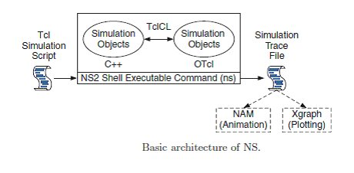

**FIG 4.1** **Basic Architecture of Ns2**

### 4.3.1 Why two language? (TCL and C++)

NS2 uses OTcl to create and configure a network, and uses C++ to run simulation. All C++ codes need to be compiled and linked to create an executable file.

**OTcl**

 - For configuration, setup, or one time simulation, or

 - To run simulation with existing NS2 modules.

This option is preferable for most beginners, since it does not involve complicated internal mechanism of NS2. Unfortunately, existing NS2 modules are fairly limited. This option is perhaps not sufficient for most researchers.

**C++**

- When you are dealing with a packet, or – when you need to modify existing NS2 modules.

This option perhaps discourages most of the beginners from using NS2. This book particularly aims at helping the readers understand the structure of NS2 and feel more comfortable in modifying NS2 modules.

**4.4 ADVANTAGES & DISADVANTAGES OF NS2**

**ADVANATAGES**

1. Cheap- Does not require costly equipment

2. Complex scenarios can be easily tested.

3. Results can be quickly obtained – more ideas can be tested in a smaller time frame.

4. Supported protocols

5. Supported platforms

6. Modularity

7. Popular

**DISADVANTAGES**

1. Real system too complex to model. i.e. complicated structure.

2. Bugs are unreliable

**CHAPTER 5**

**RESULTS AND DISCUSSION**

Simulations are done with aquasim patch using ns2 simulator.

**5.1 Simulation Parameters**

|  |  |
| --- | --- |
| **Parameter** | **Value** |
| **Area** | **500 × 500** |
| **Simulation time** | **100 s** |
| **Minimum speed** | **0.3** |
| **Maximum speed** | **1** |
| **Pause time** | **10 seconds** |
| **Number of nodes** | **100** |
| **Number of sink** | **4** |
| **Transmission Power** | **2 Watts** |
| **Receiving Power** | **0.75 Watts** |
| **Idle Power** | **0.12 Watts** |

**Table 5.1 Simulation parameters**

**5.2 Simulation module used**

Network Simulator 2 has been incorporated as the simulation model. The significance of ns2 is open source discrete event level simulator and it does not require any commercial license.

Simulation in an underwater environment is the midway between theory and experiment due to the cost and changes in ocean environment. The work lies in analysing the communication aspects for routing in aquasim patch.

To make communication effective in underwater the primary focus is upon acoustic communication for minimal lossless data transmission. Considering these criteria primarily open source software ns-2 (network simulator version 2) was used for networking, with underwater communication with various simulation patches were available such as DESERT (Design simulate Emulate Real time test beds) [19], SUNSET (Simulation emulation and real time testing for underwater sensor networks) [20], Aqua net mate [21] wherein simulation and experimental frame work with channel and modem characteristic had been used. Then, a deep insight had been made with aquasim patch [18] had been used for analysis with influence of routing protocols.

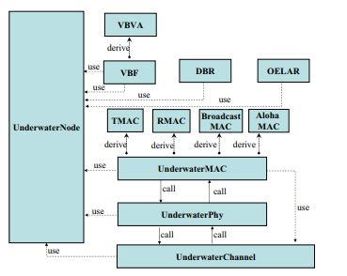

**Figure 5.1 Diagrammatic representation of Aquasim patch as in [18].**

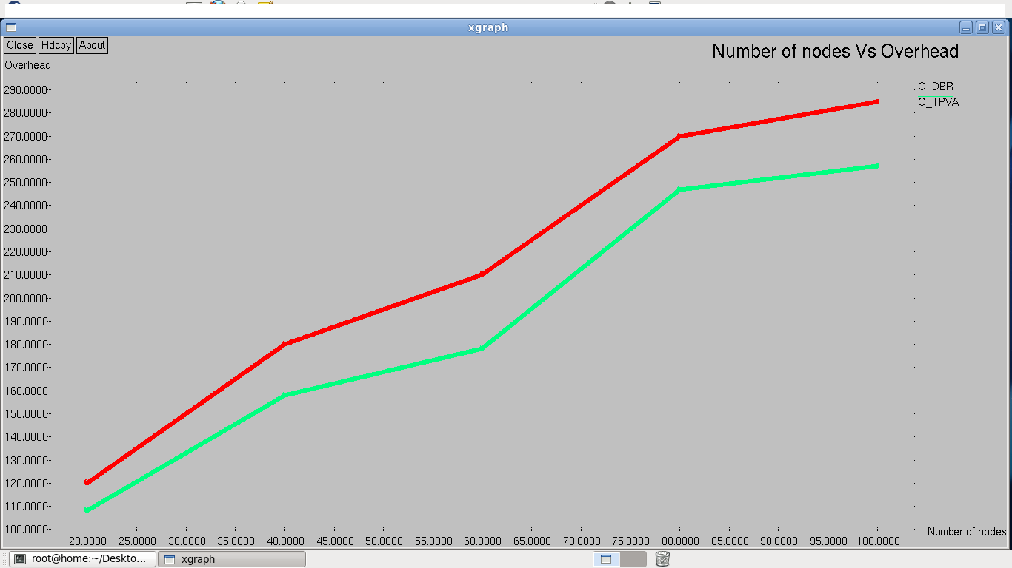

**Figure 5.2. Number of nodes versus control overhead**

The number of nodes indicates the scalability of network and the overhead indicates number of control packets exchanged for transfer of data.

The value of Figure 5.2 is being displayed in table (5.2)

|  |  |  |
| --- | --- | --- |
| **NUMBER OF NODES** | **DBR** | **TPVA** |
| 20 | 129 | 117 |
| 40 | 182 | 161 |
| 60 | 215 | 181 |
| 80 | 274 | 251 |
| 100 | 295 | 261 |

**Table 5.2 The number of nodes versus control overhead**

The reaction to communication void has been done with minimal overhead suggests the protocol performance with void handling in terms of overhead in figure 5.2.

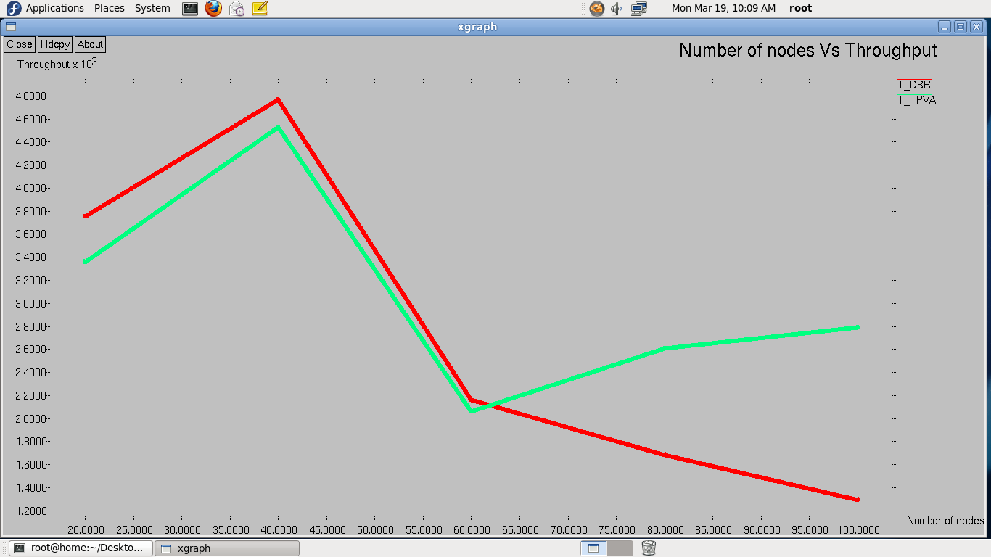

**Figure 5.3. Number of nodes versus throughput**

$$\text{Delivery ratio=}\frac{\text{Number of packets delivered}}{\text{Number of packets transmitted}}\text{ ×100}$$

|  |  |  |
| --- | --- | --- |
| **NUMBER OF NODES** | **DBR** | **TPVA** |
| 20 | 3252.30 | 3058.93 |
| 40 | 4369.82 | 3225.56 |
| 60 | 2011.57 | 1760.70 |
| 80 | 1284.39 | 2306.30 |
| 100 | 1090.68 | 2490.65 |

**Table 5.3 The number of nodes versus throughput**

The reaction to communication void has been done with delivery ratio suggests the protocol performance with void handling in terms of sink in figure 5.3.

**4.3 Increasing mobility**

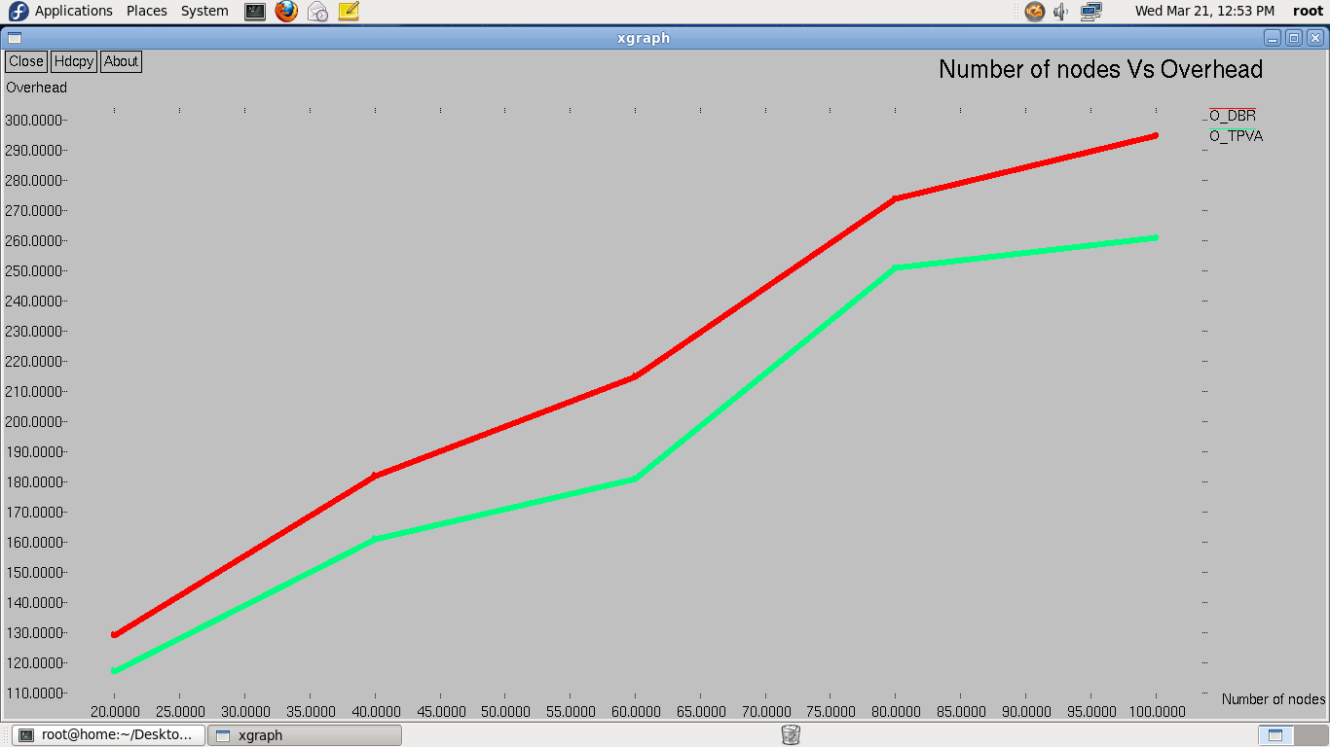

**Figure 5.4. Number of nodes versus control overhead**

Increasing mobility produce changes in network topology, hence the control overhead is subsequently increased. This is shown in above figure(5.4).

Increase in mobility cause change in network topology which have link breakage, hence the throughput is decreased

|  |  |  |
| --- | --- | --- |
| **NUMBER OF NODES** | **DBR** | **TPVA** |
| 20 | 120 | 108 |
| 40 | 180 | 158 |
| 60 | 210 | 178 |
| 80 | 270 | 247 |
| 100 | 285 | 257 |

**Table 5.4.**  **Table for** **Number of nodes versus control overhead**

The reaction to communication void has been done with minimal overhead suggests the protocol performance with void handling in terms of overhead in figure 5.4.

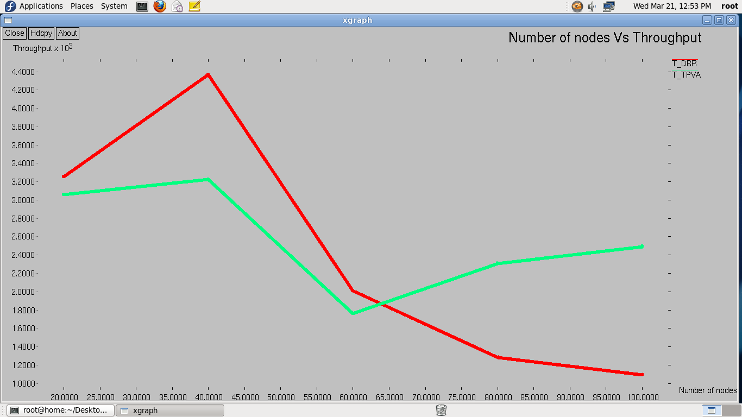

**Figure 5.5. Number of nodes versus throughput**

**Formula for throughput:**

$$\text{Throughput =}\frac{\text{No. of Received data frames × Data size}}{\text{Simulation Duration × Data rate}}$$

|  |  |  |
| --- | --- | --- |
| **NUMBER OF NODES** | **DBR** | **TPVA** |
| 20 | 3752.30 | 3358.93 |
| 40 | 4769.82 | 4325.56 |
| 60 | 2161.57 | 2060.70 |
| 80 | 1684.39 | 2606.30 |
| 100 | 1290.68 | 2790.65 |

**Table 5.5**. **Table for** **number of nodes versus throughput**

**CHAPTER 6**

**CONCLUSION AND FURTHER IMPROVEMENT**

**6.1 Conclusion**

Intersecting of transmission range with the specific sub terrain provides a proper methodology for forwarding. In addition the probability mass function provides the proper metrics of forwarding with minimal overhead rather than flooding of control packets. The state of underwater routing with proper equivalent transmission probability and unpredictable underwater sensors mobility has been worked with optimal path routing by proper forwarding at void node.

**6.2 Further improvement**

Further research in this area should concentrate on the data traffic rate needed for void node and the time coordinates it requires to overcome temporal void.

**REFERENCES**

1. Ghoreyshi, S. M., Shahrabi, A., & Boutaleb, T. (2017). Void-handling techniques for routing protocols in underwater sensor networks: Survey and challenges. *IEEE Communications Surveys & Tutorials*, *19*(2), 800-827.

2. Chen, D., & Varshney, P. K. (2007). A survey of void handling techniques for geographic routing in wireless networks. IEEE Communications Surveys & Tutorials, 9(1), 50-67.

3. Takagi, H., & Kleinrock, L. (1984). Optimal transmission ranges for randomly distributed packet radio terminals. IEEE Transactions on communications, 32(3), 246-257.

4. Younis, M., & Akkaya, K. (2008). Strategies and techniques for node placement in wireless sensor networks: A survey. Ad Hoc Networks, 6(4), 621-655.

5. .Yang, H., & Sikdar, B. (2008, November). A mobility based architecture for underwater acoustic sensor networks. In Global Telecommunications Conference, 2008. IEEE GLOBECOM 2008. IEEE (pp. 1-5). IEEE.

6. Khan, A., Javaid, N., Latif, G., Karim, O. A., Hayat, F., & Khan, Z. A. (2018, March). Void Hole and Collision Avoidance in Geographic and Opportunistic Routing in Underwater Wireless Sensor Networks. In International Conference on Emerging Internetworking, Data & Web Technologies (pp. 225-236). Springer, Cham

7.Roy, R. R. (2010). Handbook of mobile ad hoc networks for mobility models. Springer Science & Business Media.

8. Bettstetter, C., & Wagner, C. (2002). The Spatial Node Distribution of the Random Waypoint Mobility Model. WMAN, 11, 41-58.

9. Camp, T., Boleng, J., & Davies, V. (2002). A survey of mobility models for ad hoc network research. *Wireless communications and mobile computing*, *2*(5), 483-502.

10. Yu, H., Yao, N., & Liu, J. (2015). An adaptive routing protocol in underwater sparse acoustic sensor networks. Ad Hoc Networks, 34, 121-143.

11. Clark, A. M. (2008). Ocean observing systems: Science plus industry-a formula for success. Marine Technology Society Journal, 42(1).

12. Jacquet, P., & Viennot, L. (2000). Overhead in mobile ad-hoc network protocols (Doctoral dissertation, INRIA).

13. Mohapatra, P., & Krishnamurthy, S. (Eds.). (2004). AD HOC NETWORKS: technologies and protocols. Springer Science & Business Media. Pg 78.

14. Yu H., Wang Q., Yao N., Chu Y., Zhou M., Ma Y. (2017) EFAV-MERD: Expected Forwarding Area Volume and Residual Distance Mathematic Expectation Routing Protocol for UASNs. In: Wang G., Atiquzzaman M., Yan Z., Choo KK. (eds) Security, Privacy, and Anonymity in Computation, Communication, and Storage. SpaCCS 2017. Lecture Notes in Computer Science, vol 10658. Springer, Cham

15. Yu, H., Yao, N., & Liu, J. (2015). An adaptive routing protocol in underwater sparse acoustic sensor networks. Ad Hoc Networks, 34, 121-143.

16. Ghoreyshi, S. M., Shahrabi, A., & Boutaleb, T. (2015, August). An inherently void avoidance routing protocol for underwater sensor networks. In Wireless Communication Systems (ISWCS), 2015 International Symposium on (pp. 361-365). IEEE.

17. Ghoreyshi, S. M., Shahrabi, A., & Boutaleb, T. (2017, March). An Underwater Routing Protocol with Void Detection and Bypassing Capability. In Advanced Information Networking and Applications (AINA), 2017 IEEE 31st International Conference on (pp. 530-537). IEEE.

18. Xie, P., Zhou, Z., Peng, Z., Yan, H., Hu, T., Cui, J. H., & Zhou, S. (2009, October). Aqua-Sim: An NS-2 based simulator for underwater sensor networks. In OCEANS 2009, MTS/IEEE biloxi-marine technology for our future: global and local challenges (pp. 1-7). IEEE.

19. Masiero, R., Azad, S., Favaro, F., Petrani, M., Toso, G., Guerra, F., ... & Zorzi, M. (2012, May). DESERT Underwater: an NS-Miracle-based framework to DEsign, Simulate, Emulate and Realize Test-beds for underwater network protocols. In OCEANS, 2012-Yeosu (pp. 1-10). IEEE.

20. Petrioli, C., & Petroccia, R. (2012). SUNSET: Simulation, emulation and real-life testing of underwater wireless sensor networks. Proceedings of IEEE UComms 2012, 12-14.

21. Zhu, Y., Le, S., Pu, L., Lu, X., Peng, Z., Cui, J. H., & Zuba, M. (2013, June). Aqua-Net Mate: A real-time virtual channel/modem simulator for Aqua-Net. InOCEANS-Bergen, 2013 MTS/IEEE (pp. 1-6). IEEE.